**Testing report / Screenshots for Bank Management.**

**By using Postman and swagger.**

**Jwt token generated for authenticated user:**

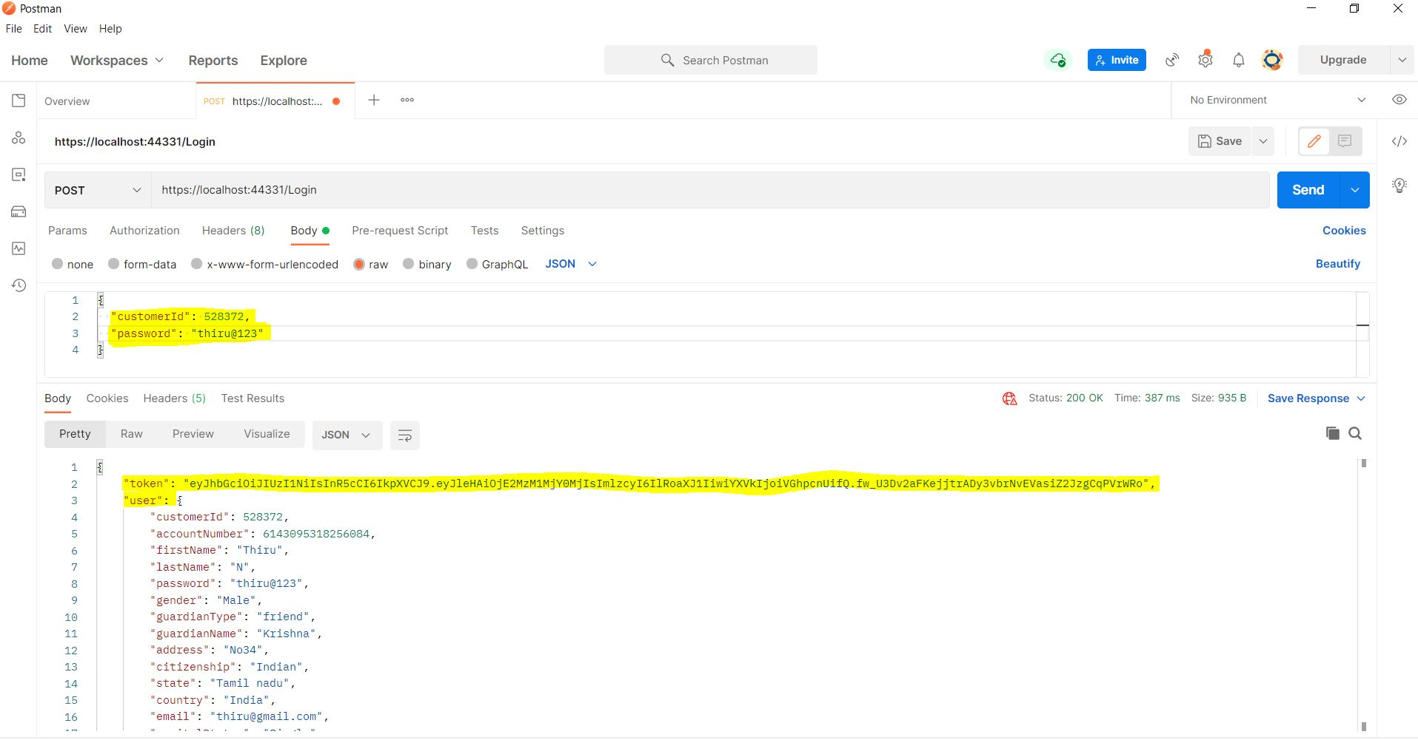

**Bad request for un authorized user:**

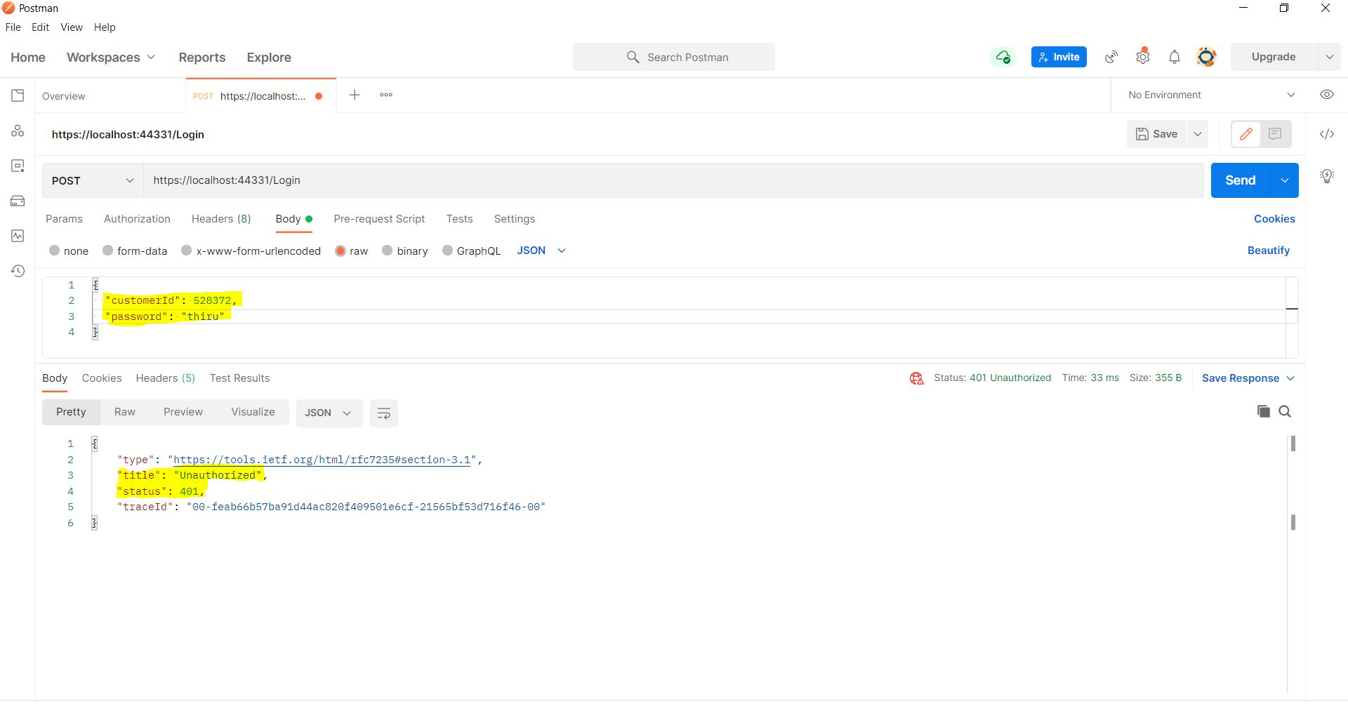

**Getting user detail by using customer Id from database:**

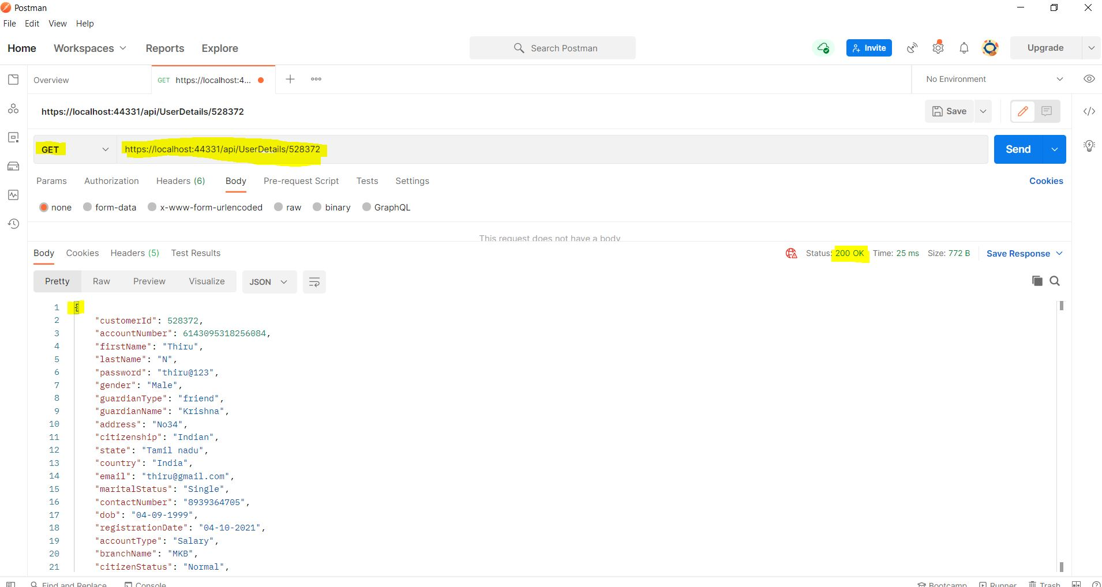

**Successfully registered for new user :**

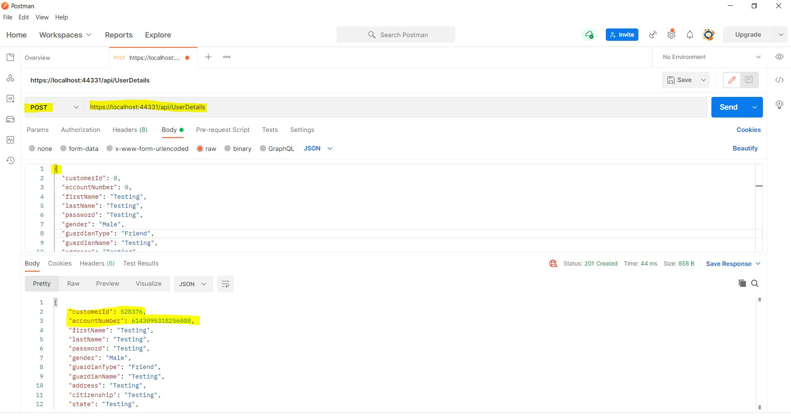

**New Register Details successfully stored in database:**

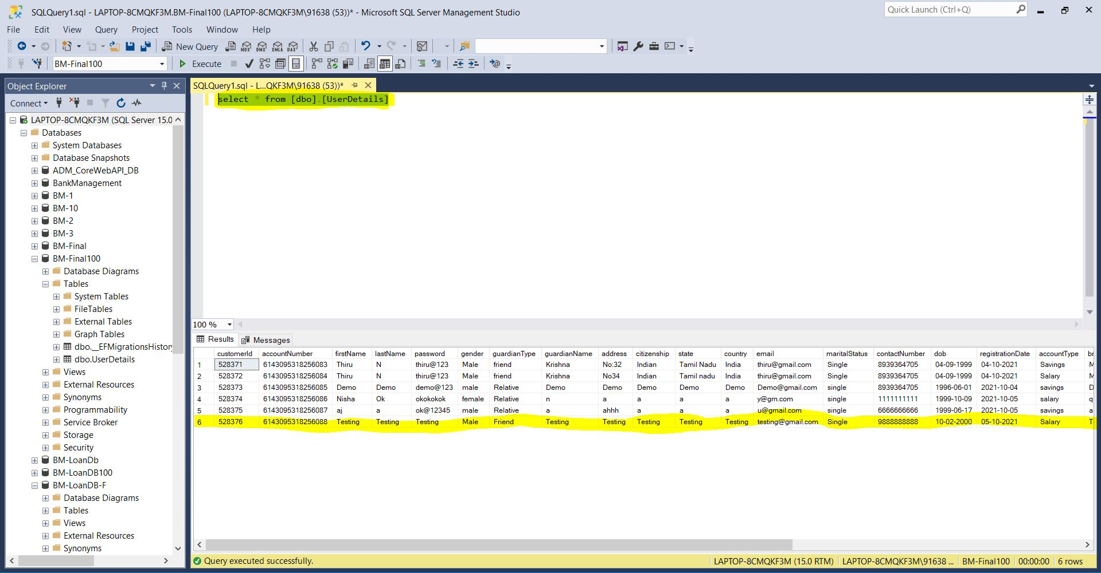

**Update user details in Swagger:**

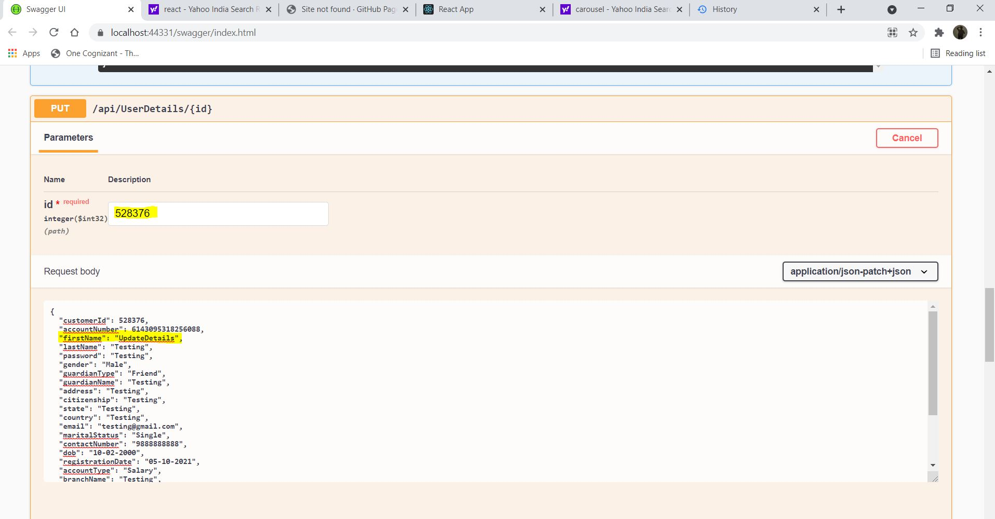

**User detail updated in database**

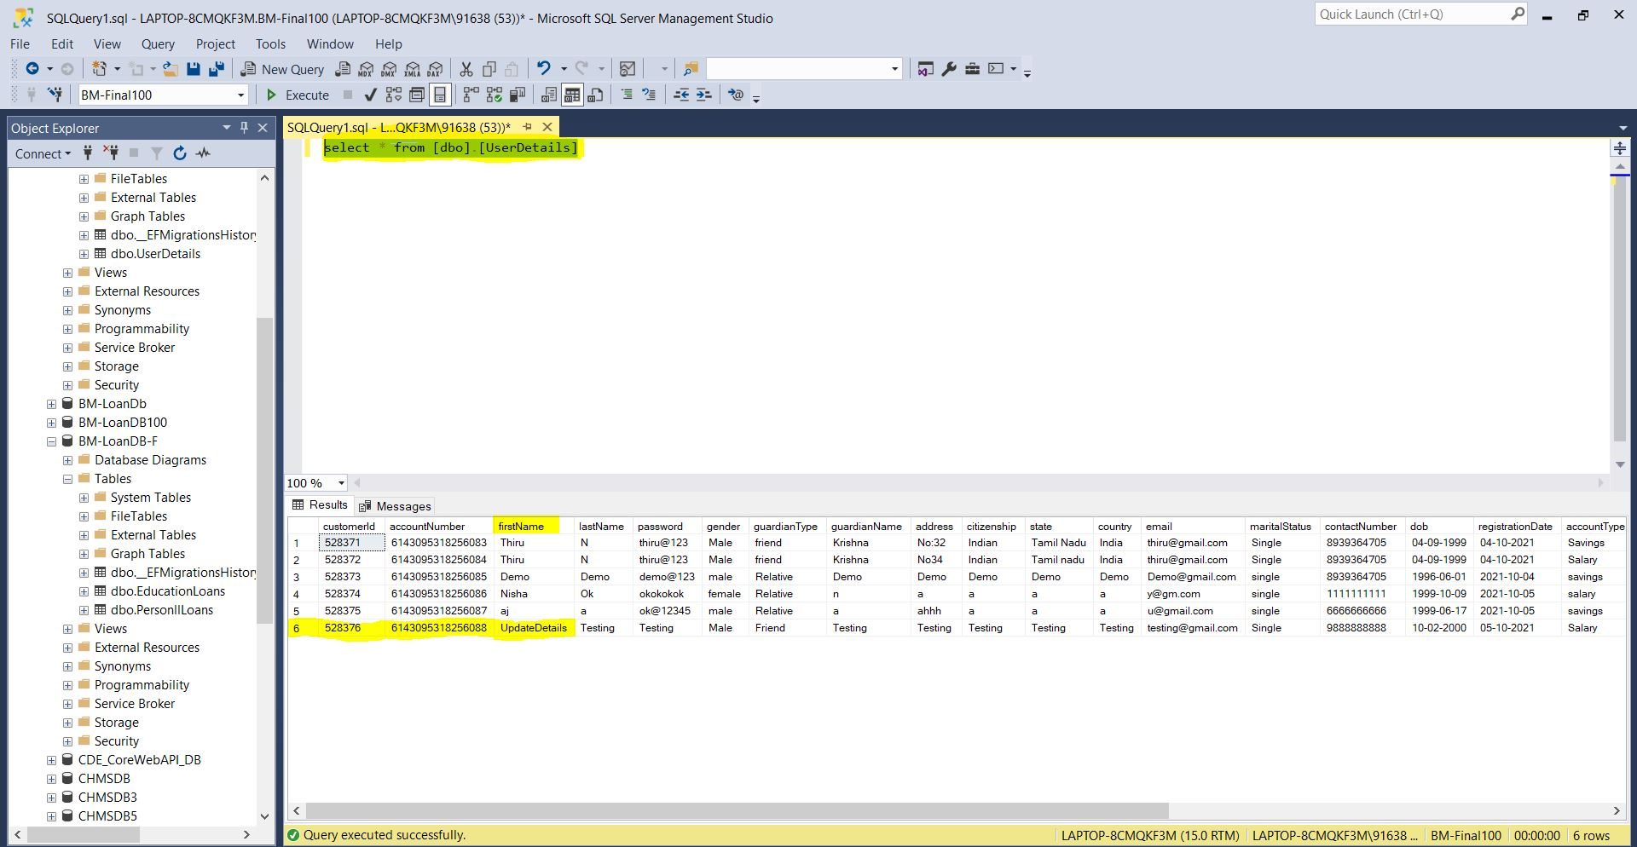

**Education loan applied in postman and returned OK status**

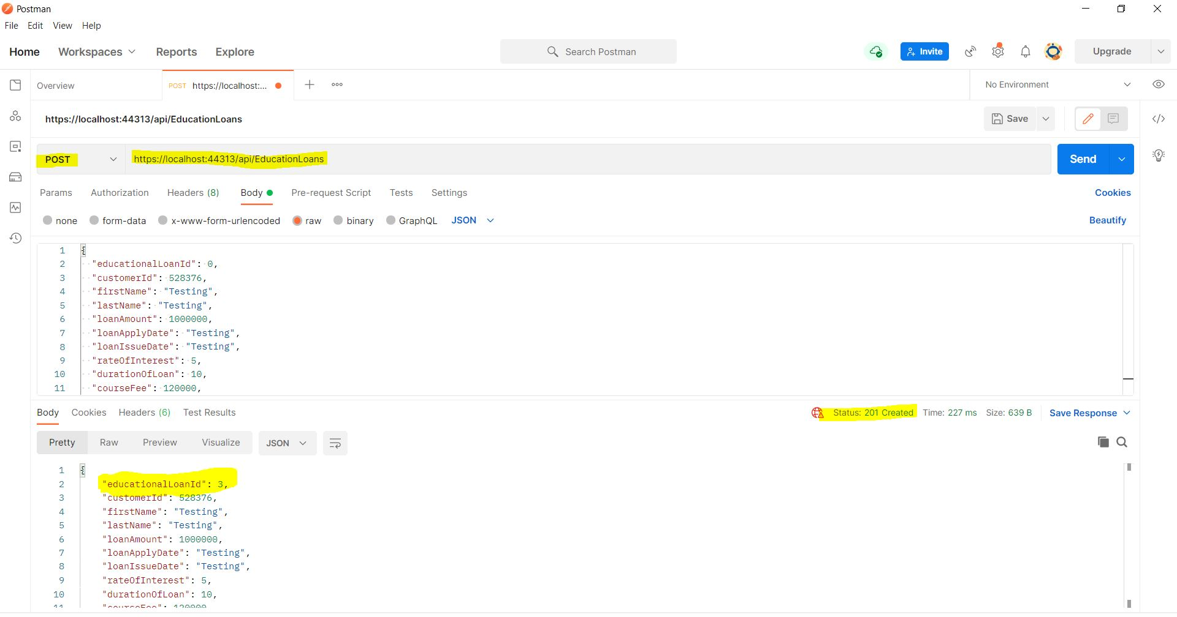

**Educational Loan details successfully stored in database**

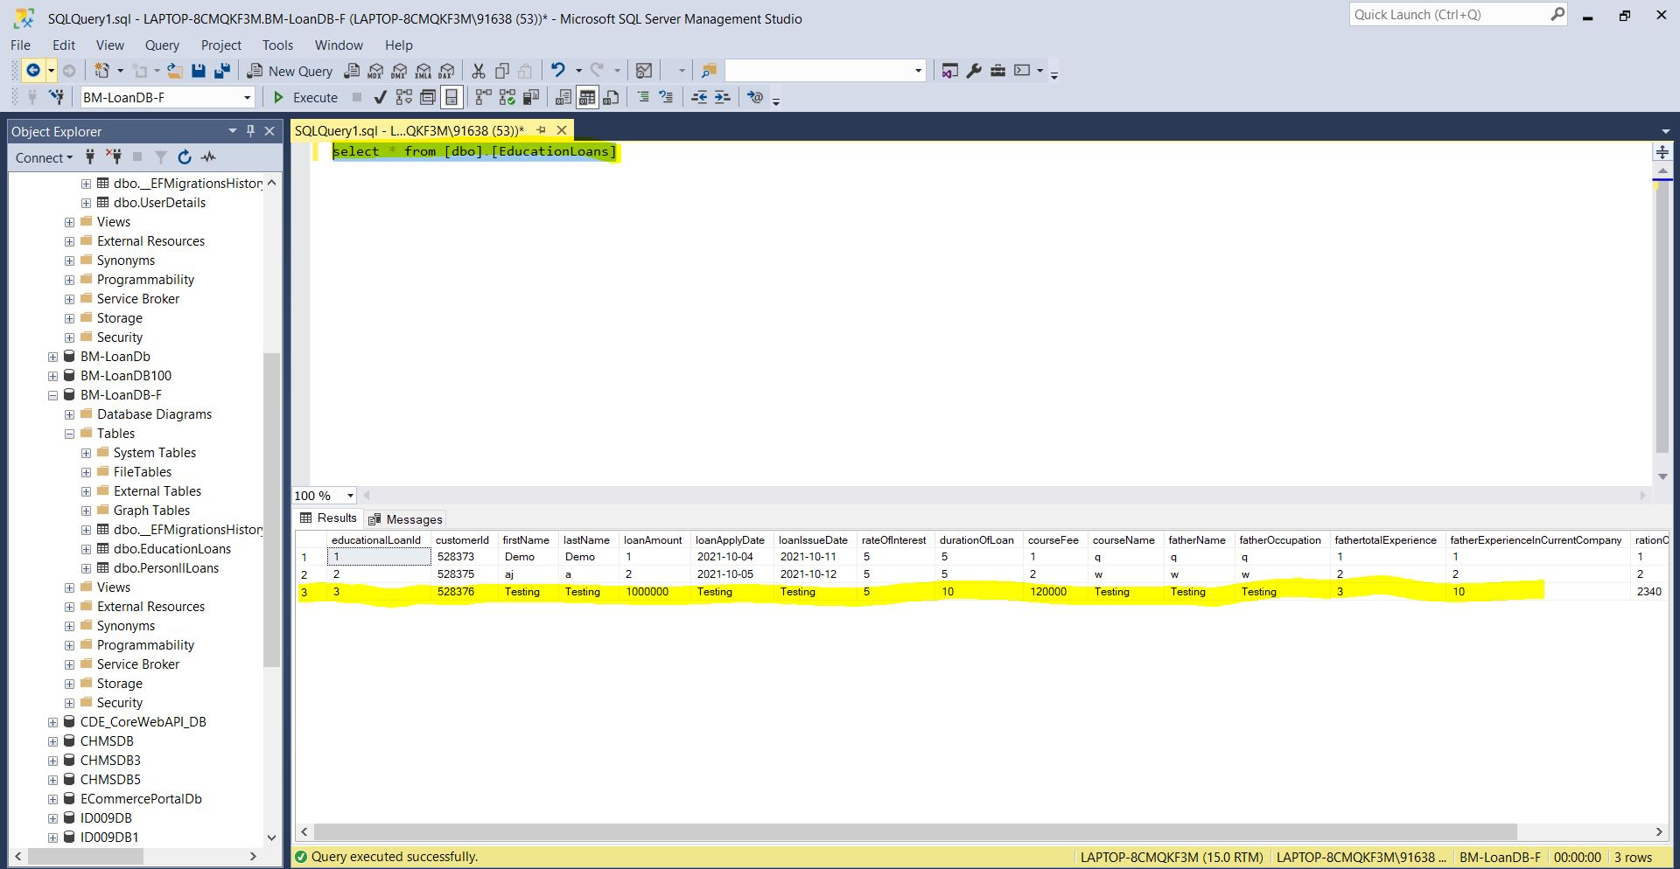

**Personal Loan applied in Postman:**

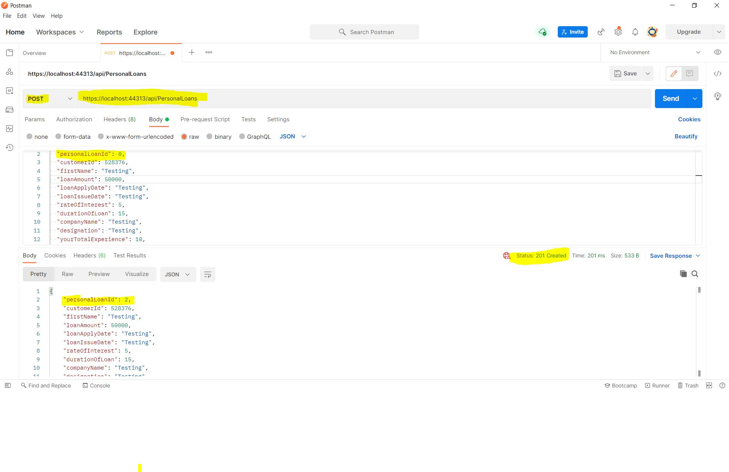

**Personal Loan details successfully stored in database**

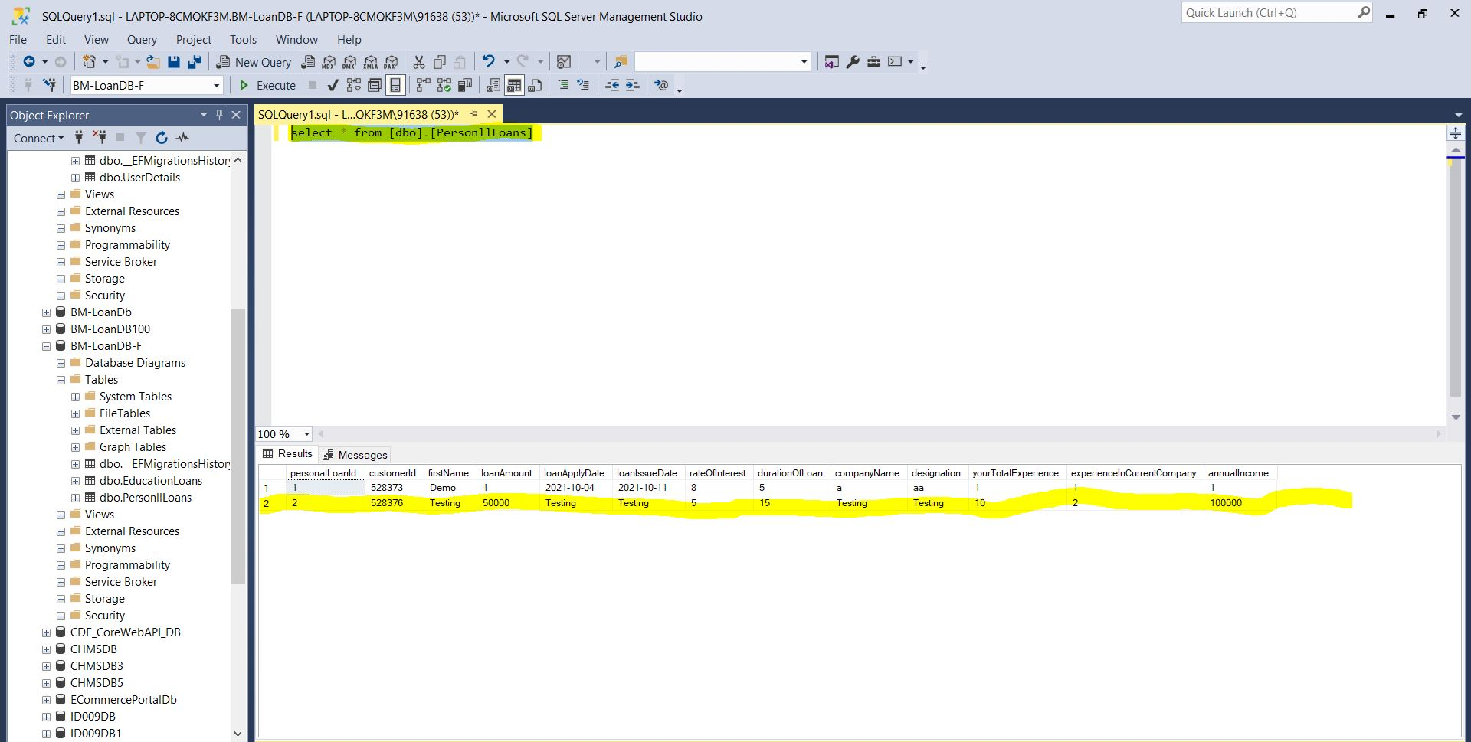

**Testing Results in UI-React**

**Registered Successfully:**

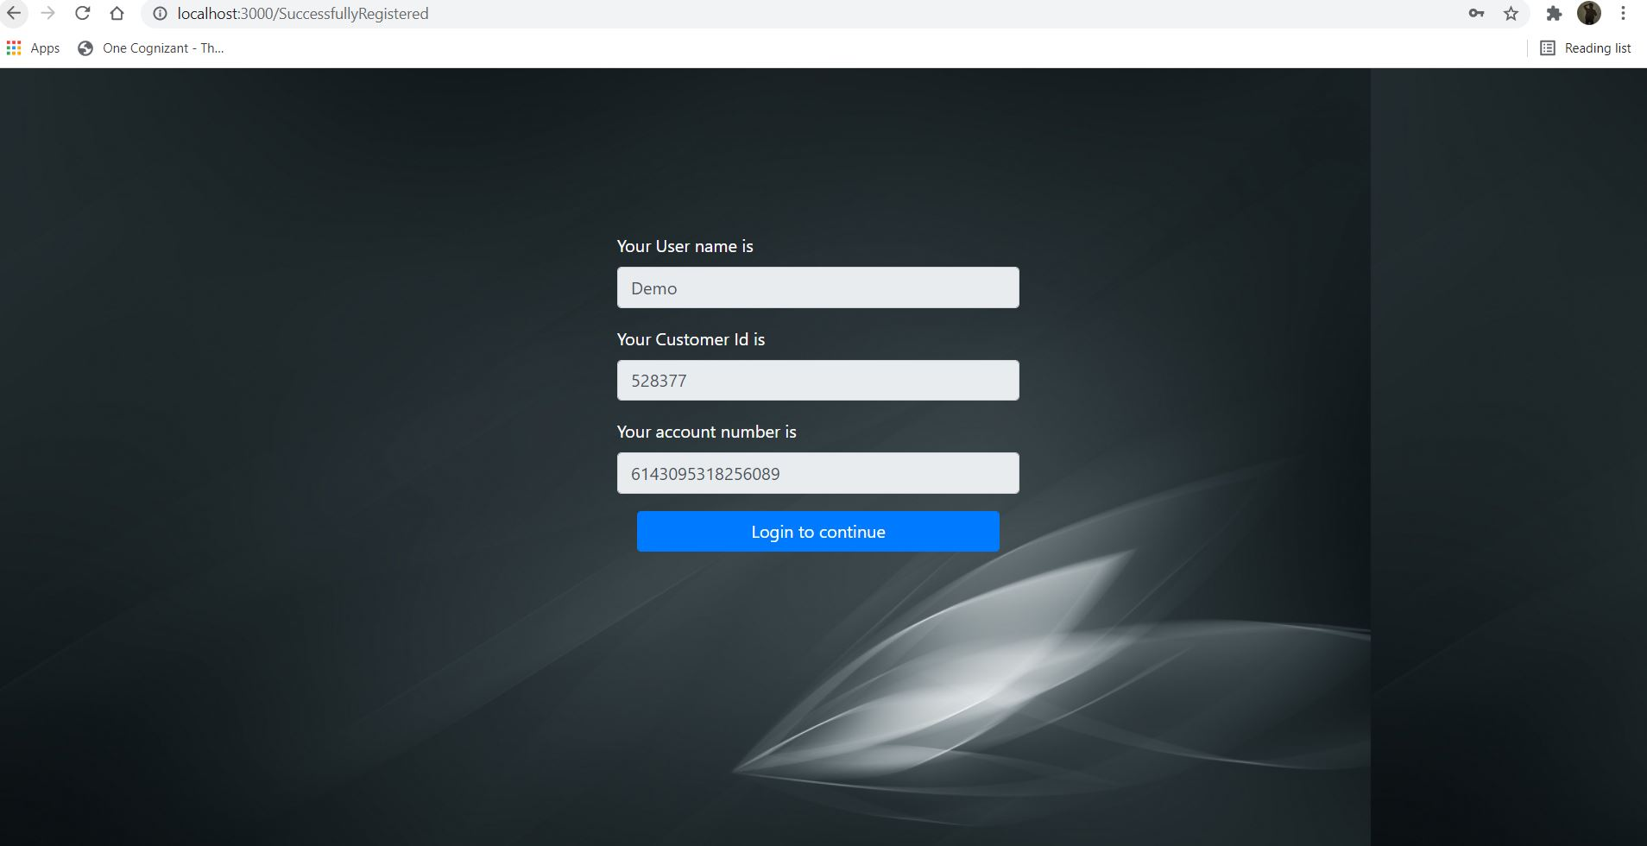

**Successfully Logged in:**

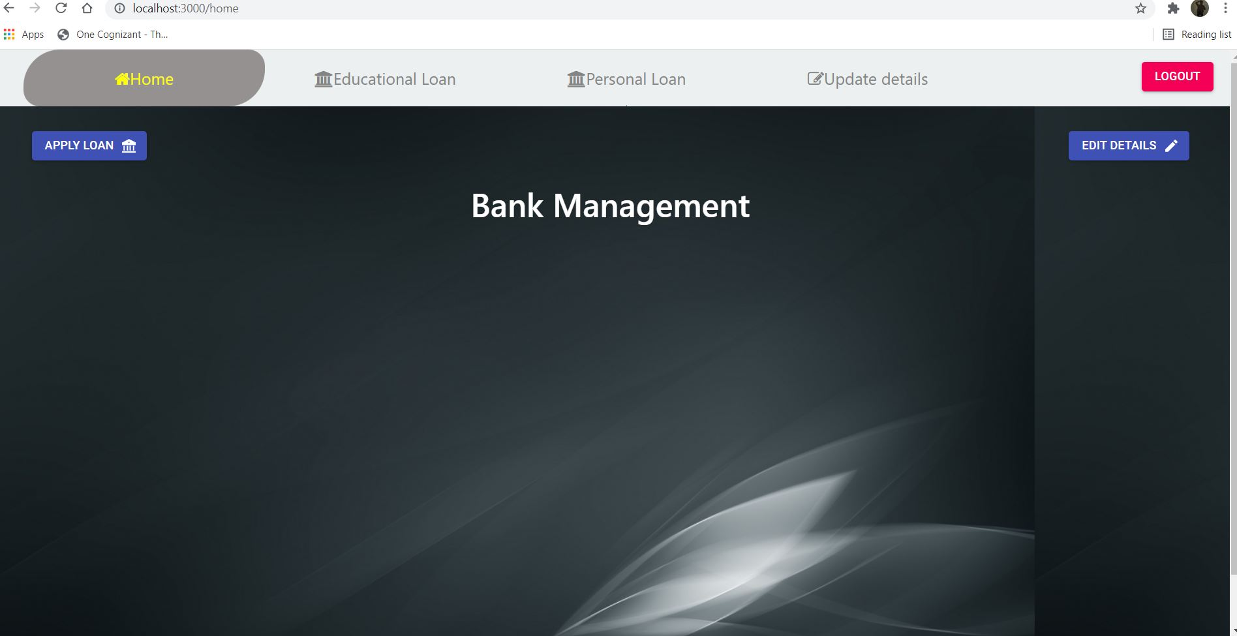

**Educational Loan applied Successfully:**

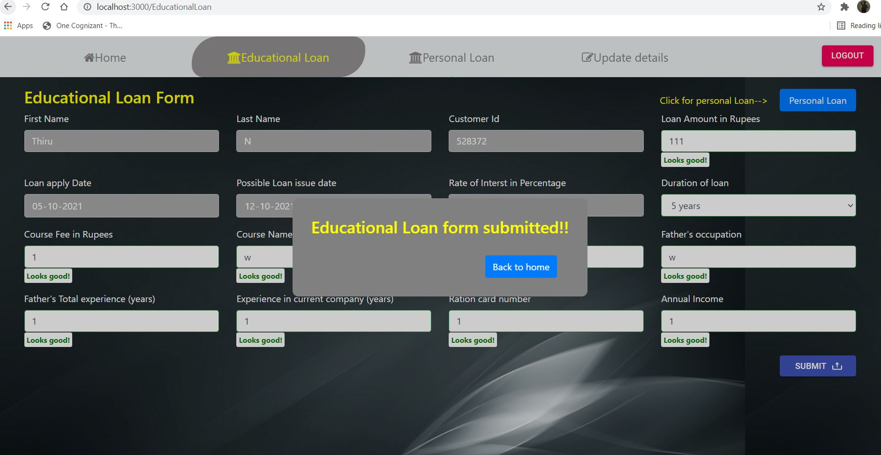

**Personal Loan applied Successfully:**

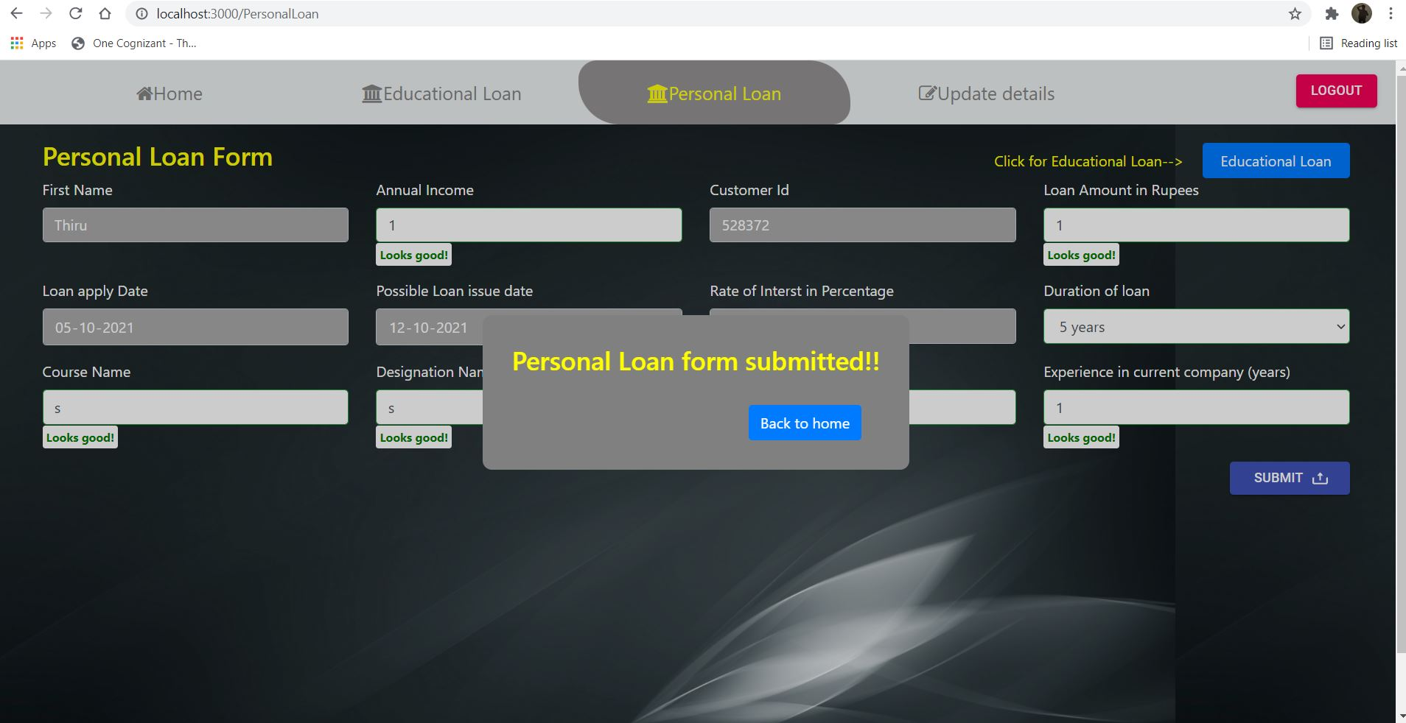

**Details Updated successfully:**

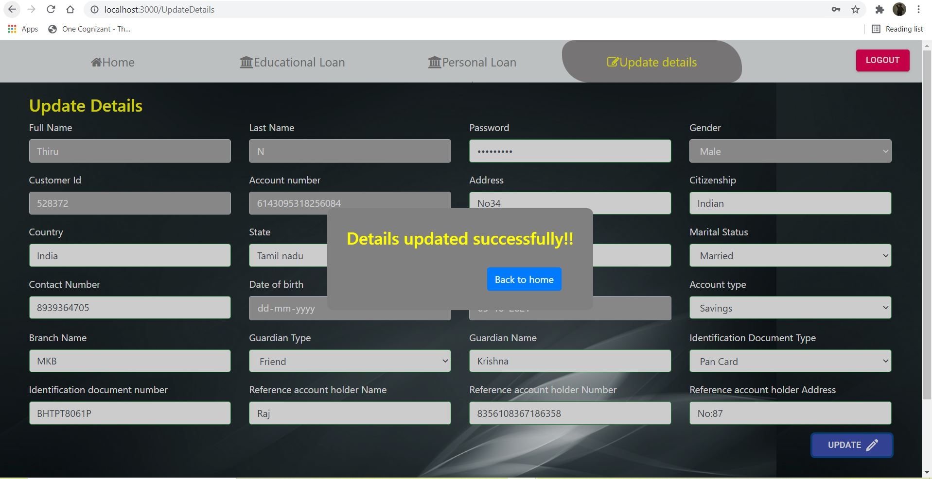

**If any error occur it will automatically redirect to error page:**

